**7AT&T Google Map Directions**

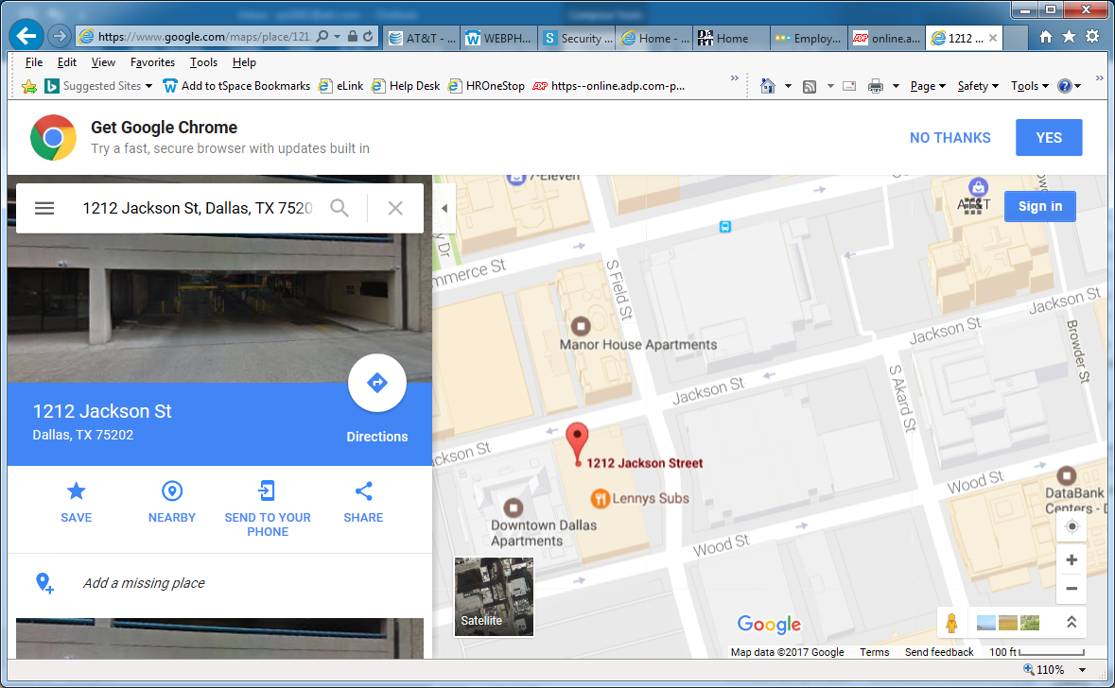

Going West down Jackson St. the 7AT&T garage located at 1212 Jackson, will be on the left hand side next the Lenny’s Sub Shop.